RESUME
Name:Aijaz Ahmad Lone
Address:Bahadurpora,Handwara
Kupwara 193221
Phone:8491959427,6005109700
Email:loneaijaz52@gmail.com
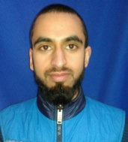
Subject:Looking to work for the greatest opportunity as computer operator or
any other field

Education:
10th pass in Govt. Boys High School Wadipora,2013
11th pass in Medical Stream at Govt Heigher Secondary School Handwara,2014
3 Months B.P.O training in Db Tech Himayat Center Handwara,2016-17
3 year diploma in Computer Engineering at Govt. Polytechnic College Leh,2019

Skills &Interests:
Working knowledge of Microsoft Word,Power point, Excel and Internet
And also Knowledge about Computer Hardware as well as Software
Database Management
Interests-Party Arrangement, Internet surfing,Cooking,Travelling

