RESUME
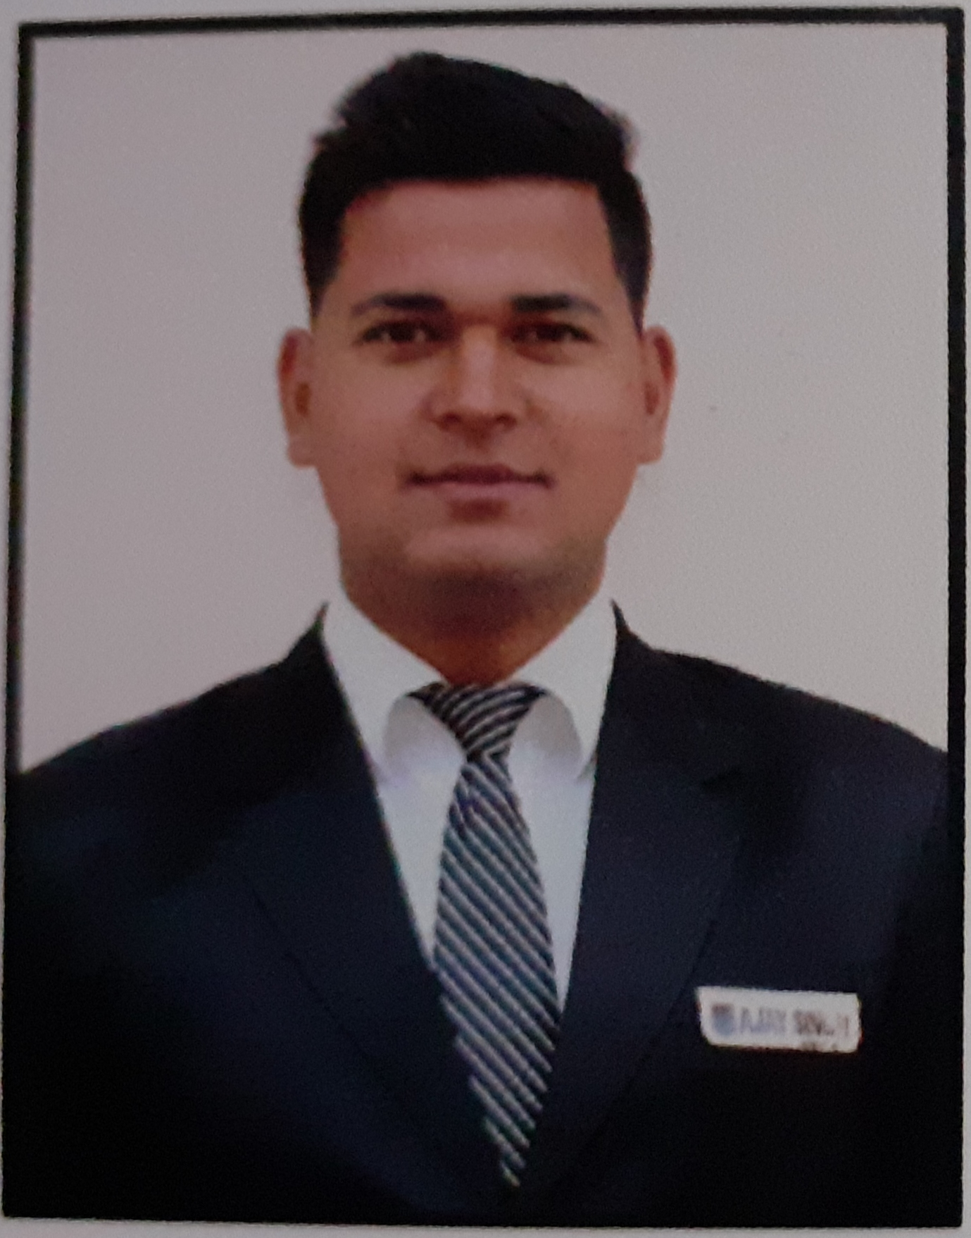
- AJAY SINGH
- Address. BANGIDHAR (SULT) ALMORA
- UTTRAKHAND

- Pin code: 263676

- Date of Birth: 20/03/1997

- E-Mail: ajaysinghrmr64@gmail.com

- Phone: 8449341220, 7060619037

- CAREER OBJECTIVE
- To be successful in whatever work I do & work an organization of
Repute which can enhance my best skills.

- Educational Qualification
- Completed B.H.M , from(KU) RCHM & C.T. BASAI RAMNAGAR UTTARAKHAND
- High school passed from (Uttrakhand Board) with first Div.
- Intermediate passed from (uttrakhand Board) with sec Div.

- Work Experience
- Currently working as GSA in F&B service department at NOVOTAL HYDARABAD AIRPORT TELNGANA 21st January 2019 to present.
- Have done 21weeks Industrial Training from Radisson blu greater Noida. January, 2017 to JUNE, 2017.
- Have done 3 month bar trending course from Delhi bar academy at renaissance collage of hotel management and catering technology.

- Career Achievements

- 2 times voice of house (employee of the month) at NOVOTAL HYDARABAD airport.
- 3 times GPL (guest performance label) winner at NOVOTAL HYDARABAD airport.

  - Software’s worked and learned

  - Micros – Point of sale.

  - Responsibilities handled along with Team leader.
- Maintaining the cleanliness & Provide best dining facilities to the guest, provide a best service in premier lounge.

- Present Individual Responsibilities
- Maintaining the Highest Level of Guest Satisfaction.
- Maintaining the service standards regarding cleanliness, food qualities & food safety.
- Maintaining the inventories of Supplies / serving items/ Equipment’s and maintain their records
- Planning and implementing of food and beverage sale.
- Always adhere to personnel grooming as per the standards laid down by the hotel and ensure that all staff in the department maintain high standards of grooming.

r
- STRENGTHS& HOBBIES
- Leadership quality
- Sincere& hard worker
- Positive Approach
- Cricket

  - PERSONAL DETAILS
- Father Name : Sh. Rampal singh,
- Mother Name : Smt.Shanti Devi
- Date of Birth : 20 march 1997
- Marital status : Single
- Nationality : Indian
- Languages Known : Hindi. English
- Gender : Male
- Passport No R 7560839 .Place of issue -- Dehradun Date of issue -- 19/1/2018

: DECLARATION

I hereby declare that the information given above is true to the best of my knowledge and believe.

Date Ajay Singh
Place Signature

