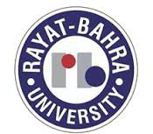
AJAY KUMAR 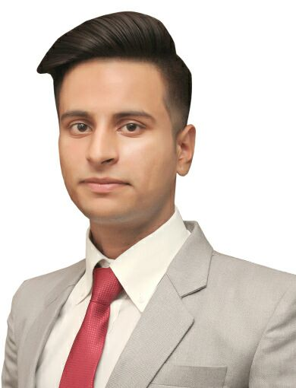
CAREER OBJECTIVE
To work in an organization, that offers a challenging role and allows me to hone my technical skills in order to develop future ready leadership qualities so I can contribute meaningfully to achievement of organisational goals.

SKILLS
- Polite & Humble.
- Assertive.
- Ready to accept challenges.
- Flexible with work.
- Effective communication & Inter-Personal ills.
- Well groomed and Attractive Personality.
- Decision Making Ability.

EDUCATIONAL QUALIFICATION

• Presently studying Master's in Tourism and Travel Management
from Indira Gandhi National open University New Delhi.
- Completed Intermediate Examination from C.B.S.E New Delhi in the year 2011 from Jawahar Navodaya Vidyalaya Samba (J&K).
- Completed Higher secondary Examination from C.B.S.E New Delhi in the year 2013 from Jawahar Navodaya Vidyalaya Samba (J&K).
- Completed Two years Diploma in Hospitality and Tourism From 2011-2013 From Jawahar Navodaya Vidyalaya Samba(J&K.)

PROFESSIONAL QUALIFICATION

- Completed 4 year Bachelor Degree of Hotel Management and Catering Technology from Rayat Bahra University, School of Hotel Management and Catering Technology which is Affiliated to Punjab Technical University, Jalandhar.

- Completed Two years Diploma in Hospitality and Tourism From 2011-2013 From Jawahar Navodaya Vidyalaya Samba(J&K).

INDUSTRIAL EXPOSURE

- Worked in Ramada worldwide, jammu as a Guest Service Associate in Housekeeping Department.

- Worked in Le Meridian Pune From 05/06/2015 to 21/11/2015 in all the Departments as a Trainee.

- Worked in Jammu & Kashmir Tourism Development Corporation Katra in major four departments Food Production, Housekeeping, Food and Beverage Service , Front Office as Trainee.

EXTRA CO- CURRICULAR ACTIVITIES

- Participated as a volunteer in Punjab Agricultural Summit organized by the Government of Punjab at Chappar Chhirri February 2014. Acted as a Guide for visitors at the summit.

- Was a part of a team of 6 students in setting up and preparing food for in food stall at Techno Virsa at 2014 in Rayat Bahra University the team achieved a sale of 25000 in 3 days.

- Led a team of 12 students in setting up and preparing food at Jawaharlal Nehru science and math’s exhibition in leisure valley Chandigarh in November 2014. Had served around 7000 students and teachers over a period of one week.

HOBBIES AND INTEREST
- Gymnastic
- Reading newspaper

LANGUAGES KNOWN
- English
- Hindi
- Punjabi

Strengths
- Confident.
- Positive Attitude.
- Working Hard.
- Highly Confident in Decision Making.
- Punctual and Self Disciplined.

PERSONAL DETAILS
- Father’s Name : Sh. Kartar chand
- Mother’s Name : Smt. Sarfo devi
- Date Of Birth : 12 feb 1996
- Height : 165
- Weight : 60kg
- Vision : 6/6

CONTACT DETAILS
Ward no 11,
P.O: samba,
Tehsil: Samba
Distt. : Samba
Jammu and Kashmir
E MAIL:ajayronny10@gmail.com
Phone: 6005407978

