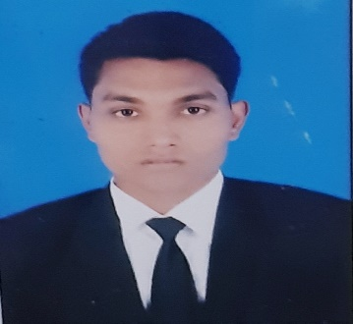
- ALOK RANJAN
Vill+po-Mahmadpur via khagaul PIN-801105
Patna
+917004885155
ralok5460@gmail.com

- CAREER OBJECTIVE

To make my career in hotel management field by using my good management skills for the mutual
growth of organization.

- EDUCATION

- IHM Hajipur
B.sc in H & HA
Pursuing

Magadh S.S central school, Nawada
Intermediate

- ACHIEVEMENTS & AWARDS
Worked as managing coordinator at 351th Prakash parv of guru Govind singh g and represented
our college.

- INDUSTRIAL EXPOSURE
17 weeks industrial training from 'Jaypee palace hotel and convention center, Agra' in four core department

- AREA OF INTEREST
Food and beverage service

- PERSONAL PROFILE

Date of Birth : 02/02/1997

Known Languages : Hindi,English

Hobbies : Traveling, Photography

- REFERENCE
Mr.Pramod sahni - "IHM Hajipur "
Training and placement coordinator
+918102058299

