Amit Yadav
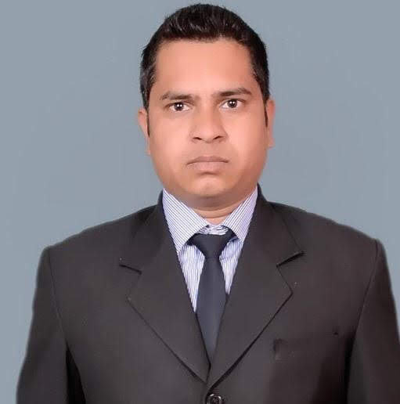
Designation - F&B Supervisor
Mobile. No. :- + 91-8102105585
Email.ID. :- amitkumardv@rediffmail.com
Skype .ID :- aykumar0786

CAREER OBJECTIVE:
- I desire to become a part of an organization which would utilized the best of my skill and which would in turn contribute to organization as well as personal development .
PROFESSIONAL QUALIFICATION:
- I have completed my 3years B.SC. In (Hotel Management) from Naincy institute of hotel management.(2007 - 2010)
ACADEMIC QUALIFICATION:
- Intermediate from Uttrakhand board.
- High School from Uttrakhand board.
COMPUTER SKILLS
Basic Computer Knowledge & internet, IDS Software & POS
INDUSTRIAL TRAINING:
- Six Months I.T( Industrial Training ) in Heritage Village Resort & Spa Manesar, Gurgaon
- Three Months V.T ( Vocational Training ) in Manu Maharani Hotel, Nainital

EXPERIENCE
- worked as f&b associate in Hotel paradise , Jaipur
(Coffee shop, Room services & Indian Restaurant ) from June 2011 to November 2011.
- worked as Sr. f& associate in Hotel Best Western Plus Levana ,Lucknow. ( coffee shop, banquet, room service & Indian Restaurant) from December 2011 to September 2013
- Worked as Sr. F&b associate in ITC Welcome The Savoy ,Mussoori
(Indian multicusine Restaurant , Room dinning ,Bar & Banquet ) from October 2013 to June 2014.
- Worked as F&B associate in Al Safiya Palace ,Ajman ( UAE) from July 2014 to June 2016.
- Worked as f&b supervisor in The Royal Garden Hotel ,sohar , Oman (Room services , banquet, multi cuisine restaurant & Chinese restaurant )
from December 2016 to November 2018.
- Worked as Barista in New Port view, Male from January 2019.

KEY SKILLS
Goal Oriented, problem solver & hard worker .
HOBBIES
- I Always Want to give full dedication towards my job & try to give happiness our surrounding.

STRENGTH
- Good decision maker
- Punctual, Self- Motivated
- Believe in schedule work.
- Hard working Honest.
PERSONAL DETAILS:
Father’s Name : Rajendra Yadav
Date of Birth : 11th Oct 1990
Nationality : Indian
Marital Status : Single
Gender : Male
Language Known. : English, Hindi, Bhojpuri & Basic Arabic
Permanent Adders. : Village – Pantnagar, dist. – Udham Singh Nagar, Uttrakhand , Pin -263145
DECLARATION:

I hereby declare that the above information declared by me is true to my knowledge.
Place- Pantnagar ( Amit Yadav)

