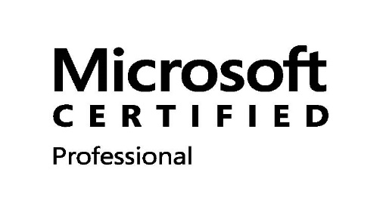
AMIT KUMAR
About Me
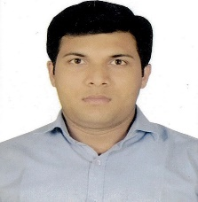
9.5 Years’ Experience
+91. 8505875152
IGI Airport T1 & T3 New Delhi
amit.dhaka@hotmail.com

https://www.linkedin.com/in/amit-kumar-02806957
July 5, 1988

IT System & Network Administrator
IT System & Network Administrator, Total 9.5 years of IT experience in providing specialised support to key Customers. Good knowledge and experience in MS Windows 7, 8.1,10 & Server 2003, 2008 R2 2012, 2016 & MAC OS Application Administration and Video Conferencing
Education

Masters, MCA Post Graduate; July 2012
Eastern Institute for Integrated Learning in Marks 69% Management University Sikkim (EIILM) Division- 1st
Bachelor, BCA Graduate, July 2010 Uttar Pradesh Rajarshi Tandon Open University Marks 65.3%
Allahabad UP (UPRTOU) Division- 1st
10+2 July 2006
Janta Inter College Mahua Bijnor Marks 53.6%
UP Board Division- 2nd
Professional Qualifications and Affiliations

- Installing and Configuring Windows Server 2012 (410) (Online Global Certification from Microsoft)
Certificate No- F986-4503
Candidate ID- MS0610084592
Marks- 88%
Passing Year- 2017

- System Engineer Network and Device (MCSE & CCNA) from HCL Infosystems Ltd.
Certificate No- 27554
Marks- 80%
Passing Year- 2012

- O Level from DOEACC (Department of Electronics Accreditation of Computer Courses) New Delhi in
Certificate No-079090
Marks- 60%
Passing Year- 2009
IT Skills
- Windows 7, 8, 8.1 & 10
- Server 2008, 2012 & 2016
- AD, DNS, DHCP, WDS, Print Server, FTP, Lync, LAN, WAN, AP, ESSL Attendance System, Video Conferencing System,
- Installing and Configuring Designing Software’s, AutoCAD, Revit, Safe, Navis, ETAB, ETAP, Pipenet, Stadd Pro, DA, Tekla, BDS, HAP, Rebar Cad, Sketch UP etc.
- LAN, WAN, Network Printer, AP Configuration, Networking, Hardware, Software, IBM Storage.
- User Complaint, Antivirus Server, Design Server, Firewall, OWA, Outlook & ERP

Work Experience

August 2019 – Current
IT Support Executive
Larsen and Toubro Ltd. B&F IC
Project Location- IGI Airport T1 & T3
Managing and Supporting Activities-
Same as previous
Work Experience
Dec 2018 –July- 2019
IT Support Executive
Talent Pro
Client Site- Larsen and Toubro Ltd. B&F IC Faridabad
Managing and Supporting Activities-
- Management all type of IT works
- To ensure the smooth operation of entire system, including Desktops, Laptops, and Servers.
- Network troubleshooting
- Manage network. Connectivity.
- Manage router.
- Manage LAN.
- Installation of workstation, server, network devices & peripherals.
- Installation & Configuration iMac & MacBook Pro MacBook Air.
- Virus protection & removal, Internet connection problem, E-mail Troubleshooting (Configuring & Troubleshooting of Microsoft Outlook clients)
- Hardware and Software Support for IBM & Fujitsu Servers & Workstations Dell, HP, Lenovo & Acer Desktop and Laptops
- Manage Global AD, DNS, DHCP & WSUS Server
- Network troubleshooting Window & iMac, MacBook Mac Book Air
- Installation & troubleshooting Hardware and Software Apple iOS X
- Installation & Troubleshooting of different application such as Adobe Acrobat, MS Office, Outlook
- Administrator of Windows Server 2008 R2, 2012 & 2016, which includes installation of server, user management, disk management & installation of service packs.
- Interacting with various vendors for sourcing products & solution and for closure of calls of certain machines, which are supported by them.
- Manage Network Heavy-duty Printer (Sharp & Canon)
- Maintaining & updating the LAN diagram of site
- Designing the back-up strategy for the site and ensuring scheduled / unscheduled back as per back-up plan & restoration
- Administrator Symantec Endpoint Protection Manager 14 Server through which remotely updates & scan client.
- Providing the Support for Microsoft Lync 2013-16
- Remotely access the Site PC & Servers and providing the Support
- Manage & Configure Cisco & Aruba Access Point (AP)
- Installation & Configure Network Printer A3, Scanner, Plotter, All-in-one
- Manage I-Clock Bio Matrix Attendance System
- Manage Dahua NVR with IP CCTV Cameras
Work Experience
Mar 2016 – Dec 2018
IT Support Executive
T&M Service Consulting Pvt. Ltd.
Client Site- Larsen and Toubro Ltd. B&F IC Faridabad
Managing and Supporting Activities-
- Management all type of IT works
- To ensure the smooth operation of entire system, including Desktops, Laptops, and Servers.
- Network troubleshooting
- Manage network. Connectivity.
- Manage router.
- Manage LAN.
- Installation of workstation, server, network devices & peripherals.
- Installation & Configuration iMac & MacBook Pro MacBook Air.
- Virus protection & removal, Internet connection problem, E-mail Troubleshooting (Configuring & Troubleshooting of Microsoft Outlook clients)
- Hardware and Software Support for IBM & Fujitsu Servers & Workstations Dell, HP, Lenovo & Acer Desktop and Laptops
- Manage Global AD, DNS, DHCP & WSUS Server
- Network troubleshooting Window & iMac, MacBook Mac Book Air
- Installation & troubleshooting Hardware and Software Apple iOS X
- Installation & Troubleshooting of different application such as Adobe Acrobat, MS Office, Outlook
- Administrator of Windows Server 2008 R2, 2012 & 2016, which includes installation of server, user management, disk management & installation of service packs.
- Interacting with various vendors for sourcing products & solution and for closure of calls of certain machines, which are supported by them.
- Manage Network Heavy-duty Printer (Sharp & Canon)
- Maintaining & updating the LAN diagram of site
- Designing the back-up strategy for the site and ensuring scheduled / unscheduled back as per back-up plan & restoration
- Administrator Symantec Endpoint Protection Manager 14 Server through which remotely updates & scan client.
- Providing the Support for Microsoft Lync 2013-16
- Remotely access the Site PC & Servers and providing the Support
- Manage & Configure Cisco & Aruba Access Point (AP)
- Installation & Configure Network Printer A3, Scanner, Plotter, All-in-one
- Manage I-Clock Bio Matrix Attendance System
- Manage Dahua NVR with IP CCTV Cameras

Work Experience

December 2014 – March 2016
IT Support Engineer
Accurate Logistics.
Nehru Place New Delhi
Client Site- Larsen and Toubro Ltd. B&F IC Nehru Place Delhi

Managing and Supporting Activities-
- Manage LAN, WAN & User Complaints of Daily Bases.
- Installation of workstation, server, network devices & peripherals.
- Virus protection & removal, Internet connection problem, E-mail Troubleshooting (Configuring & Troubleshooting of Microsoft Outlook clients)
- Installation & Troubleshooting of different application such as Adobe Acrobat, MS Office, Outlook
- Administrator of Windows Server 2003 & 2008, which includes installation of server, user management, disk management & installation of service packs.
- To ensure the smooth operation of entire system, including Desktops, Laptops, and Servers.
- Installation & Configure Network Printer A3, Scanner, Plotter, All-in-one
- Network troubleshooting
- Manage router.
- Interacting with various vendors for sourcing products & solution and for closure of calls of certain machines, which are supported by them.
- Administrator Symantec Endpoint Protection Manager 12 Server through which remotely updates & scan client.
- Remotely access the Site PC & Servers and providing the Support
- Manage & Configure Cisco Access Point (AP)
Work Experience
November 2013 – December 2014
Network Engineer
TNS Networking Solutions Ltd.
Chatarpur New Delhi
Client Site- Rail Vikas Nigam Limited (RVNL)
Managing and Supporting Activities-
- Installation & Configuration of Windows XP & 7
- Installation & Configuration of Windows Server 2003 & 2008
- To ensure the smooth operation of entire system, including Desktops, Laptops, and Servers.
- Network troubleshooting
- Manage LAN & WAN
- Provide the Internet Access on Permission Bases
- Manage Cyberoam 100i & 200i Firewall
- Manage NEC EPABX Server with VPN Calling
- Manage Cisco RV042 VPN Router
- Network Rack Maintaining & Dressing Properly
- Maintaining HP LTO Tape Drive
- Managing Dell EMC Power Edge 640 Blade Servers
- Installation & Configuration of Aruba AP
- Punching the CAT-6 Cable
- Installing the I/O with Face Plate

Work Experience
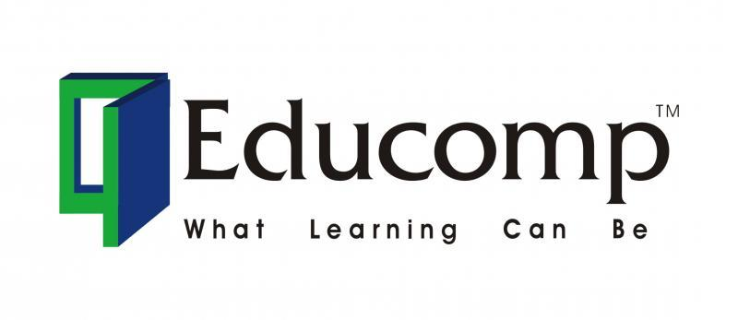

April-2012 to Nov-13
SCC (Smart Class Coordinator)
Educomp Solutions Pvt. Ltd.
Udyog Vihar Phase 3 Gurgaon HR
Client Site- Roots International School Noorpur Bijnor UP
Managing and Supporting Activities-
- Installation and Configuration Windows XP Operating System
- Manage LAN & WAN Related Issues
- Installing & Configuration Server 2003
- Managing Acer Power Series Desktop PC’s
- Configuring HP Z420 Workstation for Server
- Installation & Configuration of Infocus, Sanyo & Dell DLP projectors
- Installation the E-Tech (Smart Board) for Smart Classes
- Installation the MIMIO Device with Light Pen
- Installation of new Modules & Chapters in the Server PC
- Installation the Server Patch
- Installation Symantec Antivirus
- Installation the Online UPS
- Full Hardware & Software Support
- License Pupation & Activation
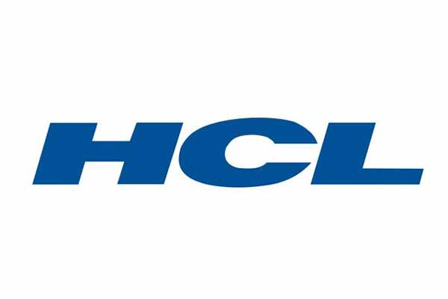
Work Experience

Octover-2010 to April-2012
System Administrator
HCL Infosystems Ltd.
HCL CDC Bijnor UP
Managing and Supporting Activities-
- Installation and Configuration Windows XP Operating System
- Manage LAN & WAN Related Issues
- Installing & Configuration Server 2003
- Managing HCL Desktop PC’s
- Installation & Configuration of Sony DLP projector
- Installation of some software’s (MS Office, Adobe Reader, Antivirus, Tally, Drivers Software, etc…)
- Installation the Online UPS
- Full Hardware & Software Support
- PC Assembling & installation of OS
- Internet Connectivity
- Data Backup Scheduling
Work Experience

Sept-2009 to Sept-2010
Network Admin
Aptech Ltd. Bijnor UP
Aptech Education Center
Managing and Supporting Activities-
- Installation and Configuration Windows XP Operating System
- Manage LAN & WAN Related Issues
- Installing & Configuration Server 2003
- Managing Laptop & Desktop Computers
- Installation & Configuration of projector
- Installation Symantec Antivirus
- Full Hardware & Software Support
- PC Assembling & installation of OS
- Managing BSNL Broadband Connection for Internet
- CAT-6 Cable Punching with RJ-45 Connector
- Installation of some software’s (MS Office, Adobe Reader, Antivirus, Tally, Drivers Software, etc…)
Computer Proficiency

- MS Office 2013-16
- Design Software’s- AutoCAD, EAB, Safe, RC Cad, Staad Pro & Revit Installation
- Planning Software Primavera P6 Installation
- Windows & Servers
- Hardware & Software’s
- Computer Assembling & T-Shooting of the PC
- Video Conferencing T-Shooting
- Office 365 OWA
- Outlook Configuration
- L&T EIP Portal
- Networking
- IP V4 Configuration
- IBM Backup Storage with Server
Languages

- Hindi
- English
Personal Interests
- Motivated and Organizational Skills
- Fully-dedicated while working
- Ready to take actions
- Time Punctuality
Personal Details

Father’s Name: Mr. Radheshyam Marital Status: Married
Birthday: July 5, 1988 Nationality: Indian
Gender: Male
Declaration
I, Amit Kumar, hereby declare that the information contained herein is true and correct to the best of my knowledge and belief.

____________________________
AMIT KUMAR New Delhi
Date:-

