CURRICULLUM VITAE
Mr. BALKRISHAN 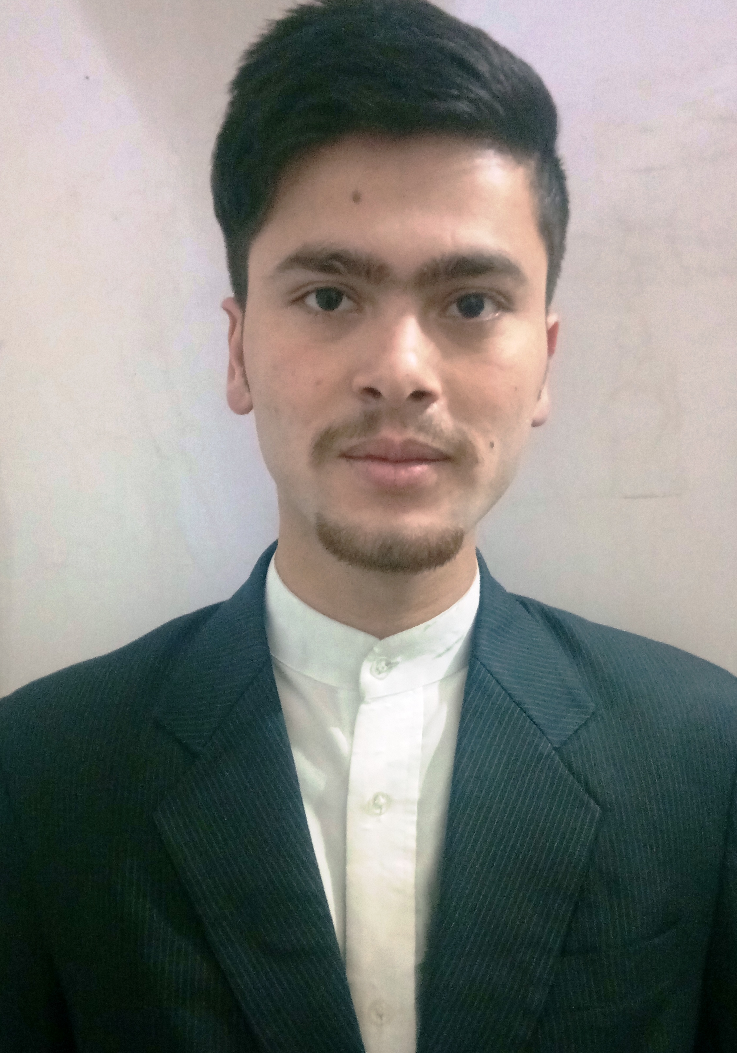
S/o Sh. Karam Singh
Vill- Baldawa P.O. Kamrau

Tehsil- Paonta Sahib
Distt.- Sirmour ( H.P.) ,pin- 173029

Mob:- 8091755613
E-Mail:- nituthakur848@gmail.com

OBJECTIVE

To work in a professional environment which brings out the very best in me; helps me learn new things and provide growth opportunities.

EDUCATIONAL QUALIFICATION

- Matriculation from H.P. Board of School Education Dharamshala.

- Intermediate from NIOS. Delhi

PROFESSIONAL EDUCATION

- One year Diploma in Hotel Management from Doon Technology & Computer Pvt. Ltd. Paonta Sahib H.P.

Training

- Six Months Industrial training (All Departments) from White Meadows by Mahindra Holidays at Manali Prini Himachal Pradesh.

- Best Trainee award of the month for September 2015.

EXPERIENCE

- Duration: - 01st April 2018 to Present.
Working as an Captain at Golden Tulip Manali.

- Duration: - 01st Dec 2017 to 01st Dec 2018.
Worked as Sr. Steward at Country Inn and Suites by Carlson (Bathinda).

- Duration: - 10th March 2016 to 10th Sept 2016..
Worked as Steward at Holiday inn (Chandigarh).

Job Responsibilities
- Handling the Restaurant Shift-in charge of 72 covers restaurant with 05 team of stewards.
- Taking Restaurant briefing on daily basis.
- Maintaining the SOP standards of the Restaurant.
- Ensuring Guest satisfaction.
- Handling different thematic events in terms of Food and Beverage.
- Maintaining Cleanliness of the Restaurant and other restaurant outlets.
Computer Skills
- MS OFFICE - MS Word, MS Excel & Internet Etc.

STRENGTHS:-

- Punctuality, flexibility.
- I always carry a positive attitude.
- Confidence to take up any challenge.
- Strong communication skill.

HOBBIES
- Making Friends
- Reading Books
- Listening Music

PERSONAL DETAILS
Father’s Name : Sh. Karam Singh
Nationality : Indian
D.O.B : 17-09-1996
Gender : Male
Martial Status : Unmarried
Domicile : Himachal Pradesh
Language known : Hindi & English

DECLARATION

I declare that all the statement mentioned above is real and true to best of my knowledge and belief.

Date ………..

Place………. BALKRISHAN

