CURRICULAM VITAE

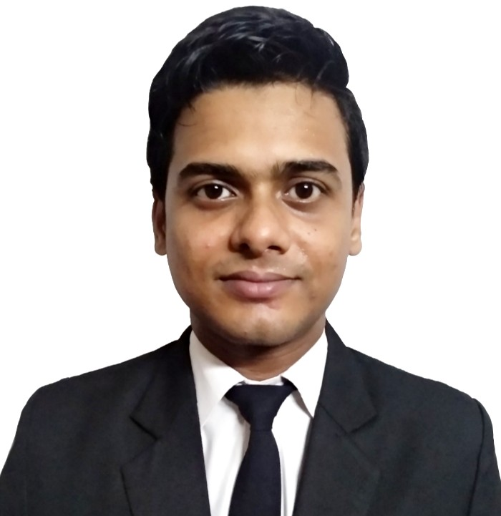
BIKROMJIT SETT
Address: Vill-Ramchandrapur, P.O. – Sankrail
P.S.-Sankrail, Dist- Howrah
Contact: 7686841374/8240820545
e-mail: bikromjitsett95@gmail.com

CAREER OBJECTIVE:

I would like to involve myself in a challenging environment, offering scope for professional growth and development and an opportunity to apply my learning towards effective contribution for the achievement of the organizational goals.

ACADEMIC QUALIFICATION:
Name of Examination | Board / University | Year | Percentage
12th | WBCHSE | 2013 | 61.00%
10th | WBBSE | 2011 | 72.00%

PROFESSIONAL QUALIFICATION:
- I am a student of COSMOPOLIS INSTITUTE OF MANAGEMENT STUDIES, Behala, Kolkata-34,
Appeared 3rd year (final) B.Sc. in Hotel Management & Catering Science from BHARATHIAR UNIVERSITY.

IT SKILL:
- Basic knowledge of computer & working knowledge on MS Word , Excel & Power Point
TRAINING:
Industrial Training /Vocation Training
- I have successfully completed my 6 months Industrial Exposer Training from ‘TAJ BENGAL’ Kolkata, from 9th May 2018 to 9th November 2018, in coffee shop Cal 27for 4month and in Butchery & Grade Manger for 2 month.

Casual Training

During my hotel management studies most of the weekend and week days after class hours I have done casual training to these following hotels and still continuing.
- 90 days (approx.) casual training from ‘HYATT REGENCY’ Kolkata, in Banquet ‘F&B’ service department.
- 100(approx.) day’s casual training from ‘TAJ BENGAL’ Kolkata, in Banquet ‘F&B’ service department and 6 days in kitchen(Butchery).
- I have worked as trainee restaurant order taker approximately for 100 days at ‘GRIND RESTRO CAFE’, Kolkata
- 60 days(approx.) vocational training from ‘THE EMPRESS PALACE’, Nagpur in ‘F&B’ service department from 1st November 2017 to 30thDecember 2017.
- 3 days casual training from ‘SWISOTEL’, Kolkata at Banquet in ‘F&B’ service department.

Learning & Observation During Training Period

Administrative

• I have learnt and developed the habit to come in work at correct time with correct uniform & standard appearance and I have to maintain the high standard of grooming at all times.
- I have learned how to hand over all the duties to next shift after completion of my shift.
- I was very punctual at my work place.

Salesmanship and Wastage controlling

• I have learned how to maximize the revenue by up selling & minimizing the cost by controlling the wastage and miss use.

Training and Human Resources Management

• During training I attended all training session & maintained 100% attendance
• I have learned in case of any emergency/sickness I always have to inform HR and HOD of the departments
• I have learned Hotel and departmental SOP.

Guest Service Handling & Other duties-CAL27(Coffee shop) & Banquet

• I have learned how to do the mise-en-place for coffee shop (CAL27), Banquet room set up, Banquet table sate up as well as side station and how to set up a a-la-carte and Table d hote table sate up and the buffet sate up for Breakfast, Lunch and Dinner.
- I have learned how to maintain a pleasing personality so that guest can feel comfortable
• I have learned how to maintain a high standard of order taking at all times and how to do upselling & to fulfill all guest requirements.
• I have learned to handle any guest complaints in the correct manner and in according to the hotel procedures & to be able to work in all shifts
• I have learned how to check stocks and how to make a list of requisition for CAL27
• During my training period I observed all departmental Fire, Emergency and I also observed where the fire exits, fire extinguishers & all safety things are.
• Health and Safety policy and procedures

Learning & observation - Butchery & Grade Manger

During my training period at Butchery & Grade Manger I learned how to maintain hygienic & keep the places clean and sanitize the equipments.
- I know different types of meat cuts, fish cuts and I have seen different types of salads & carvings.

PERSONAL INFORMATION:
Father’s Name : Babulal Sett Date of Birth: 04.03.1995
Marital Status : Single
Nationality : Indian
Language : English, Hindi, Bengali
Hobbies : listening and singing songs
Strength : I am very hard working & dedicated person, and I also have willing to learn ability.

ACHIEVEMENT:
I have competed in national level competition for 3 times in YOGA, (ALL INDIA YOGA CULTURE FEDERATION)

REFERENCE:
Mr. Parijat Guin (Director of Cosmopolis Institute Of Management Studies): 8420029777
Ms. Sowmya Sengupta (Learning & Development Manager at Taj Bengal Kolkata): 8697711331

DECLARATION:
I hereby declare that all the information’s given above are true to the best of my knowledge.

DATE:
PLACE: (BIKROMJIT SETT)

