CURRICULUM VITAE
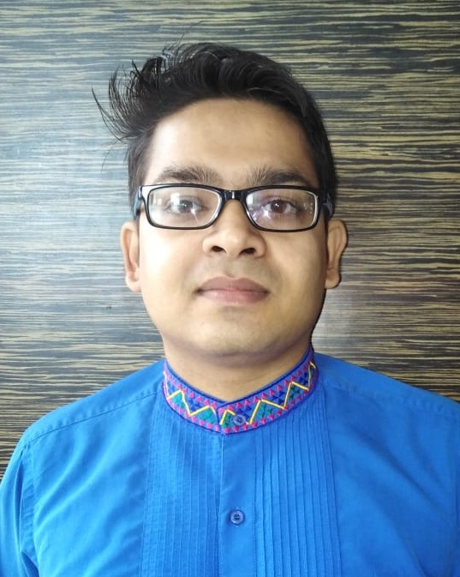
DEVANG PANDEY
Mob. : - +91 8318880950 Email: - devangpandey13@gmail.com

CAREER OBJECTIVE: Seeking a deserving profile in the hospitality sector, where I can deliver me expertise an innovative hospitality skills, while maintaining the integrity and work ethics of the working environment, thereby maintaining the reputation of the organization.

QUALIFICATION:
- Passed 10th from MARY GARDINARS CONVENT SCHOOL .
- Passed 12th from JANTA INTEER COLLEGE.
- B.Sc.(PCM) FROM SHUBHARTI UNIVERSITY.
- Training from Fortune Park Dahej,Gujarat

- Pursuing MBA in hotel and tourism management , SVSU,Meerut
COMPUTER KNOWLADGE:
- Diploma in Networking and Hardware.
DUTIES AND RESPONSIBILITIES:
- Taking care of Check-in and Check-out for the day.
- Making C-form and doing Pathik( For Indians)
- Making the reservations and handling the concierge service.
- Doing the Night Audit.
- Preparing the Next day arrivals with their respective mails.

EXPERIENCES:

- 1.5year experience in Fortune Park Dahej, Gujarat, as GSA in Front Office on I.D.S Software.
- Currently working as Front office Supervisor in ITC Welcome Heritage Ta do a Vanya Villas Nagpur from last 6 months

STRENGHTS:
- Flexible in Nature and taking up the new responsibilities.
- Hardworking & Systemic in work.
- Positive & Polite Attitudes towards every responsibility.

INTERST & HOBBIES:
- Travelling.
- Playing Tabla.
- Exploring the new cities.
- Enjoy with different kinds of culture

PERSONAL DETAILS:
- Father’s Name :- Mr Praveen Kumar Pandey
- Mother’s Name:- Mrs. Hemlata Pandey
- Sex :- Male
- Date of Birth :- 02Nov.1995
- Nationality :- Indian
- Religion :- Hindu
- Marital Status :- Single
- Permanent Add. D-154 sec d LDA colony Kanpur road Lucknow, Uttar Pradesh .

DECLARATION: I conform myself having an adequate knowledge about the work mention in CV. I am also confident of my ability to work in a team.

Date:-24,Sept.,2020 Devang Pandey
