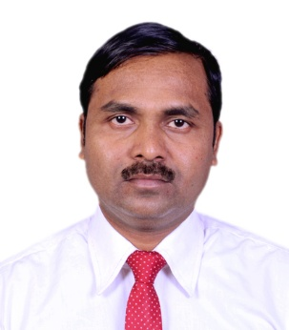
Curriculum Vitae
Dhires Chandra Ghorai
E-mail ID:- dhireschandraghorai@gmail.com
Mobile No:- +919609126121,+919830087137

OBJECTIVE
To be part of a team in a large professionally managed organization and grow to a responsible level using my knowledge and skills. Learn new technologies and best utilize my skills for the organization.

EDUCATIONAL QUALIFICATION
Passed B.A.(Hons)

OTHER QUALIFICATIONS
- Passed Trade Certificate Course In cookery From Food Craft Institute,Darjeeling
(S/B Ministry of Tourism Govt. of India & Govt. of West Bengal)
- Passed Advanced Diploma In Financial Accounting System From Lake Town,Kolkata
(Department of Sports and Youth Services & Govt. of West Bengal)

PERSONAL PROFILE
Father’s Name :- Late Sasadhar Ghorai
Date OF Birth :- 02nd of April, 1972
Nationality :- Indian
Religion :- Hindu
Gender :- Male
Martial Status :- Married

HOBBIES
Reading Book, Listening Music, Public Relationship.

LANGUAGES KNOWN
Hindi, Bengali, English and able to communicate in Nepali

EXPERIENCES
- 3 Months Industrial Training in Hotel Hindusthan International, Kolkata
- 3Years Working Experience as Management Trainee in Elgin Groups of
Hotels, Darjeeling.
- 3Years Working Experience as a Chief Cook in Hotel Sinclairs , Portblair, Andaman
Islands.
- 3Years Working Experience as a Chief Cook at Dolphin Restaurant , Portblair, Andaman.
- 7Years Working Experience at Hotel Sremon Inn, Kolkata
- Presently working with Hotel Prime Murti , Dooars .

ADDRESS FOR CORRESPONDENCE
Dhires Chandra Ghorai
Vill Tangrakhali,P.O. Byabattarhat
Dist Purba Medinapur
Pin: 721648
West Bengal.

DECLARATION
I hereby declare that the above particulars are true to the best of my knowledge and belief.
Date:03. 09 . 2020 Yours Truly,

____________________________
Place: Kolkata [ Dhires Chandra Ghorai ]

