BIO-DATA 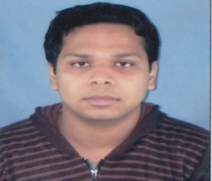
NAME : KOUSTAV CH GHOSH
FATHER’S NAME : KARTICK CH GHOSH
ADDRESS : NOAPARA KALIBARI ROAD BARASAT
PO+PS BARASAT KOLKATA- 700124.
CONTACT NO : 9051589248, 8296333430
DATE OF BIRTH : 18/09/1987
MARITAL STATUS : SINGLE
SEX : MALE
RELIGION : HINDU
NATIONALITY : INDIAN
CAST : OBC
EMAIL : koustavrbu@gmail.com
EDUCATIONAL QUALIFICATION :
EXAMINATION PASSED | BOARD/UNIVERSITY | YEAR OF PASSING | DIVISON
MADHYAMIK | CBSE | 2005 | 2ND
HIGHER SECONDARY | CBSE | 2008 | 1ST
B.A. (ENGLISHHONOURS) | RBU | 2011 | 2ND
M.A.(ENGLISH ) | RBU | 2013 | 2ND
BED | WBUTTEPA | 2018 | 1ST
CBSE TET | CBSE | 2019 | 1ST
OTHER QUALIFICATION : DIPLOMA IN COMPUTER APPLICATION.
LANGUAGES KNOWN : ENGLISH, BENGALI AND HINDI
PLACE: BARASAT
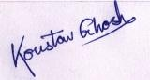
SIGNATURE

