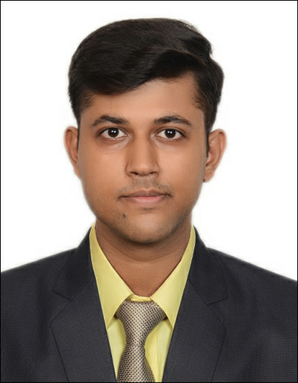

Name: Nikhil Chaurasia
Contact Number: +91- 9930130814
E-Mail: nikhilchaurasia5@gmail.com
Date of birth: 5th September 1995

Permanent Address: 37, Amar Singh Marg, Freeganj, Ujjain (M. P.) 456010
Correspondence address: 37, Amar Singh Marg, Freeganj, Ujjain (M. P.) 456010

CAREER OBJECTIVES:

Seeking for a job in a challenging and healthy work environment where I can utilize my skills and knowledge efficiently for organizational growth.

SCHOLASTIC PROFILE

YEAR | NAME OF INSTITUTION | COURSE | PERCENTAGE
2012 | St. Paul’s Convent Sr. Sec. School | SSC | 64%
2014 | St. Paul’s Convent Sr. Sec. School | HSC | 65%
2015 | IHMCTAN, Mumbai | Semester 1 –  BSc in H & HA | 68.95%
2016 | IHMCTAN, Mumbai | Semester 2 –  BSc in H & HA | 66.95%
2016 | IHMCTAN, Mumbai | Semester 3 –  BSc in H & HA | 61.80%
2017 | IHMCTAN, Mumbai | Semester 4 –  BSc in H & HA (Industrial Training) | 84.50%

Industrial training:
ITC Grand Central, Mumbai (17 Weeks)

Achievements:
Letter of Appreciation from Front Office Manager, ITC Grand Central (Mumbai)

Computer Literacy

Proficient in MS Office
Basic knowledge of Java and MySql
Basic knowledge of Opera and IDS

Research

To study the marketing strategies followed by Pop-up restaurants.

Extra-Curricular Activities:

Played Cricket and Basketball at School Level
Track and field running

Hobbies:

Photography
Traveling
Cooking
Playing Cricket and Basketball

Linguistic Abilities

Language | Speak | Read | Write
Hindi | YES | YES | YES
English | YES | YES | YES

Personal Profile

Father’s Name : Sanjay Chaurasia
Mother’s Name : Sunita Chauasia

References:
Name: Dr. Francis Thomas  Designation: Senior Lecturer  Organization: IHMCTAN, MUMBAI  Contact details: thomasfrancis2010@gmail.com  Mobile No. : +91- 9967074446 | Name:  Designation:  Organization:  Contact details:

