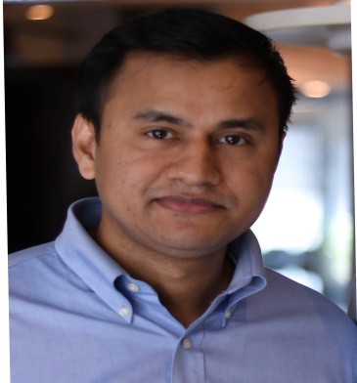 Prem Singh
37 Ko Shing St Flat A
Sheung wan,Hong Kong
Mob: +852 91970115
+852 51170314
E-mail: mehta.prem365@gmail.com

CAREER OBJECTIVE
To work in a dynamic and challenging environment, Where I can learn and apply my knowledge and
Potential which is best for organization and Individual Professional growth.
EDUCATIONAL QUALIFICATION
- B.A from H.N.B Garhwal University in 2009
- Intermediate from C.B.S.E. Board in 2006.
- High School from C.B.S.E. Board in 2004.
PROFESSIONAL QUALIFICATION
- Distance MBA in Hospitality Management from MIBM Global.
- Hotel Management from RAM INSTITUTE OF HOTEL MANAGEMENT AND
CATERING TECHNOLOGY (RIHMCT) Dehradun India.

EXPERIENCE
Assistant Restaurant Manager ( UHG Hospitality Nov 2017 to Till the date )

- Ensure all customers are provided with outstanding service.
- Effectively manage staff with positive and effective motivation.
- Handling & Interacting on the guest comments,complaints.
- Ability to assess food quality and presentation and ensure quality control.
- Formulate and recommend changes to improve employees' performance and teamwork..
- Plan and coordinate menus,working closely with the head chef.
- Responsible for performing administrative duties including payroll,supliers,inventoy control & cash handling
- Closely working with marketing team to develop special promotional and merchandising plans,advertising,materials.
Anantara Hotels Resorts and Spa Abu Dhabi ( Aug 2015 to May 2017)
Senior Food & Beverage Associate

- Ensure customer satisfaction through promoting excellent service.
- Respond to customer complaints tactfully and professionally
- Analyze staff evaluations and feedback to improve the customer’s experience
- Ensure cleanliness and sanitation of the restaurant area as per the safety and sanitation standard of department
- Project future needs for goods,kitchen supplies and cleaning products
- Seek ways to cut waste and decrease operational costs

Warwick International Hotels and Resorts Dubai ( March 2014 to June 2015)
Food & Beverage Associate

- Worked with as a preopening Team Member in ‘French and South American Restaurant’
- Look after the day to day operations of Restaurant.
- Handling Guest relation and complaints.
- Delivered high levels of customer service according to standards.
- In charge of maintaining monthly inventories.
- Furnished efficient, prompt and courteous service.

Intercontinental Hotels and Resorts Dubai ( Nov 2012 to Feb 2014)
Food & Beverage Associate in Events

- Worked as a food & Beverage Associate in Events
- Responsible for day to day operations of Banquet.
- Handling Guest relation and complaints.
- Delivered high levels of customer service according to standards.
- Handled corporate functions and Conferences.
- During my tenure I was involved in smooth running of day to day banquet operations.
- I was actively Involved in outdoor events

INDUSTRIAL EXPOSURE

- 22 weeks of Internship from Radisson Blu suites''Gurgaon India.
- Worked with all Food & Beverage Outlets.
- Got appreciation letter from ‘Radisson Blu’ during Internship.

KEY ATTRIBUTES

- Comfortable working with the people of diverse backgrounds and ability to work under stress.
- A keen learner.
- Good interpersonal skills.
- Team spirit.

PERSONAL DETAILS

Father’s Name : Shri Diwan singh
Date Of Birth : 10-03-1987
Martial Status : Married
Nationality :Indian
Language Known : English & Hindi

