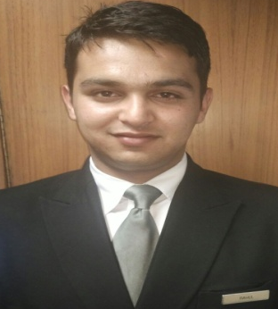
CURRICULUM VITAE

RAHUL GAUTAM

Contact | E-mail | Address
+91 9418539969 | rgautam14.91@gmail.com | Vivek Niwas, Neridhar, Bhattakuffar , Sanjauli Shimla-06 (HP)

Objective | To obtain challenging and responsible position in an organization where in I contribute to the successful growth of an organization using my abilities and knowledge. “There is always a better way of doing things” is the common belief.
Professional Qualification | - Master Degree in Computer Application from SMU  - PGDCA form NIELIT DOEACC Shimla.  - Certification in ASP.NET 4.5 from CS Info Tech Chandigarh.
Academic Qualification | - B.A from H.P.U Shimla in 2012.  - +2 from H.P Board Dharamshala in 2009.  - 10th from H.P Board Dharamshala in 2007
Technical Skill | - LAN Networking , Wi-Fi Network  - Computer Hardware : PC Assembling and Troubleshooting  - Knowledge of Computer Programming and .Net Technology
Operating System Environments | Microsoft Windows  Microsoft Windows Server  Demonstrated expertise in Microsoft Windows XP, 7, 8 and 10.
Responsibility | Resolves internet related issues.  Network monitoring.  Monitoring guest services.
Relevant Skills | - Effective working as an individual & as co-operative team members.  - Motivated and enthusiastic about developing good relation with employees.  - Professional in appearance and presentation.
Hobbies & Interests | - Internet Surfing  - Listening music
Additional Skills | - OPERA PMS (V5.0.04.01)  Opera Client Installation  User Configuration  User Creation  - MICROS (POS)  User Configuration  Creation / Modification / reconfiguration of existing or new items for sale.  - SAP  Installation
Experience | - Worked as Customer Support Engineer at Hotel The Oberoi Cecil Shimla through Sysnet Global Pvt. Ltd from October 2015 to 2017.  - Worked for two month as Executive helpdesk at HotelThe Oberoi Cecil Shimla through Microsense Pvt. Ltd.  - Currently working as Network Engineer in The Oberoi Cecil Shimla under Reliance Jio.

Personal Sketch

Name | Rahul Gautam
Father’s  Name | Sh. Pratap Chand Gautam
Date of Birth | 14th Dec. 1991
Sex | Male
Nationality | Indian
Marital Status | Single
Languages Spoken | Hindi, English
Strengths | My optimistic thinking and parents.
Declaration | “I do here by declare that all the statements mention above are correct and true to the best of my knowledge and beliefs”.

Date:
Place: (Rahul Gautam)

