CURRICULAM VITAE
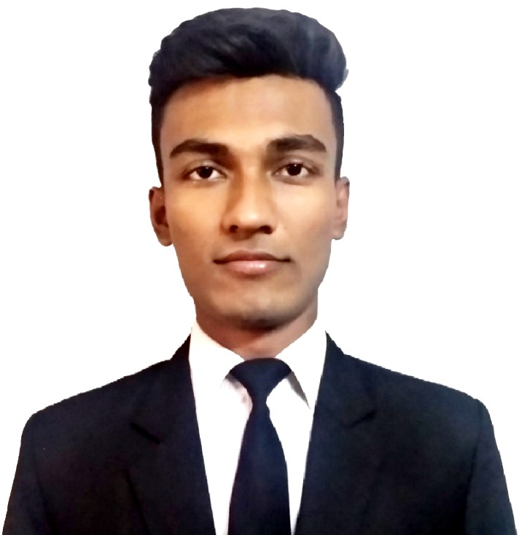
RAMIT CHAUDHURI
Address: Vill-Goatgeria, P.O. – Balichak
P.S.-Debra, Dist- West Medinipur
Contact: 8768075704
e-mail: chaudhuriramit9@gmail.com

CAREER OBJECTIVE:

I would like to involve myself in a challenging environment, offering scope for growth and development and an opportunity to apply my learning to effectively contribute towards the achievement of the organizational goal.

ACADEMIC QUALIFICATION:
Name of Examination | Board / University | Year | Percentage
12th | WBCHSE | 2016 | 68.00%
10th | WBBSE | 2014 | 65.00%

PROFESSIONAL QUALIFICATION:
- I am a student of COSMOPOLIS INSTITUTE OF MANAGEMENT STUDIES, Behala, Kolkata-34,
Appeared 3rd year ( final) B.Sc. in Hotel Management & Catering Science from BHARATHIAR UNIVERSITY

IT SKILL:
- Basic knowledge of computer & working knowledge on MS Word , Excel & Power Point
TRAINING:
Industrial Training /Vocation Training
- I have successfully completed my 6 months Industrial Exposer Training from ‘Taj Bengal,Kolkata’ from 9th May 2018 to 9th November 2018, in coffee shop Cal 27for 4 month and Bakery for 2 month.

Casual Training
During my hotel management studies most of the weekend and week days after class hours I have done casual training to these following hotels and still continuing.
- 90 days(approx.) casual training from ‘HYATT REGENCY’ Kolkata, at Banquet in ‘F&B’ service department.
- 180(approx.) days casual training from ‘TAJ BENGAL’ Kolkata, at Banquet in ‘F&B’ service department.
- 2 days casual training from ‘JW Marriott Hotel Kolkata’.
- 60 days(approx.) vocational training from ‘THE EMPRESS PALACE’ in ‘F&B’ service department from 1st November 2017 to 30thDecember 2018.

- 3 days casual training from ‘SWISOTEL’ at Banquet in ‘F&B’ service department.

Learning & Observation During Training Period

Administrative

• I have learned that I have to come in work at proper time with proper uniform & standard appearance
• I have to maintain a well standard grooming at all time

Developing Salesmanship and concern about wastage controlling

• I have learned how to maximize the revenue by upselling,suggestive selling & minimize the cost by controlling wastage

Training and Human Resources Management

• During training I attended all training session & maintained 100% attendance
• I have learned in case of any emergency/sickness I always have to inform HR and HOD of the departments
• I have learned Hotel and departmental SOPs

Guest Service Handling

• I have learned how to carry a pleasing personality with smile in front of the guest so that the guest can feel comfortable and remember the journey as an experience
• I have learned how to maintain a high standard of guest experience at all time

Learning & Observations - Bakery & Confectionery

• I have learned how to sanitized the place
• I have learned how to make dough and cookies
• I have learned how to make chocolate garnish
• I have learned how to make different types of nuts chocolate

Learning & Observation - Cal 27 (Coffeeshop)

• I have learned how to do the mis-en-place over there & cal 27's private party as well as side stations
• I have learned how to do the restaurant Ala-Carté table set-up for Cal 27, Table d-hote for private function and also learned how to set-up the buffet for breakfast lunch and dinner.
• Sometimes I have to take orders and place the orders from kitchen counter and doing clearance and setting up the morning breakfast set-up.

Health & Safety

• Hotel fire procedure
• Hotel Health and Safety policy and procedures
• Emergency handling procedure
• Personal hygiene and sanitation
• Food handling with proper hygiene

PERSONAL INFORMATION:
Father’s Name : Ranjit Chaudhuri Date of Birth : 29.11.998
Marital Status : Single
Nationality : Indian
Language : English, Hindi, Bengali
Hobbies : Playing guitar, listening and singing songs, Photography
Strength : I am very hard working person having willing to learn ability,
Self motivated and pro-active

ACHIEVEMENT:
I was a participant of Regionals India Skills Competition 2016 under the category of Resturent service organized by Tourism and Hospitality Skill Council supported by NSDC, Skill India, India Skills 2016 and CII.

REFERENCE:
Mr. Parijat Guin (Director of Cosmopolis Institute Of Management Studies): 8420029777
Ms. Sowmya Sengupta (Learning & Development Manager at Taj Bengal Kolkata): 8697711331

DECLARATION:
I hereby declare that all the information’s given above are true to the best of my knowledge.

DATE:
PLACE: (RAMIT CHAUDHURI)

