Sir/Madam,
With regards from Rana, currently I am working as "Deputy Manager- Housekeeping" in " Clarks Shiraz" Agra, since November 2018. It is a 5 star deluxe property run by “U.P.Hotel Ltd.”. It is 237 rooms property.
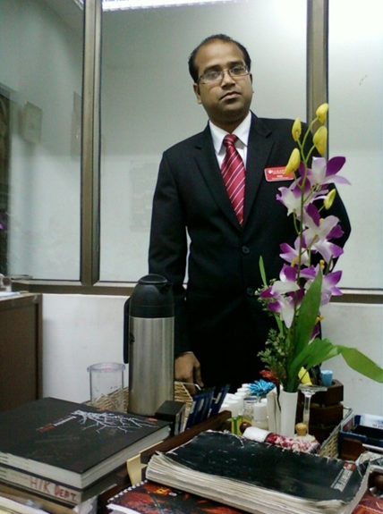

Personal Information

Name : RANA DHAR
Date of Birth : May 14, 1977
Gender : Male
Contact Information

Email-Id : ranadhar77@gmail.com
Country : INDIA
Current Location : Agra.
Phone : (M) 09635350466 /07596880602

Work Experience

- Worked as "Executive Housekeeper" in "Ramada Resort" Kumbhalghar, Rajasthan, since January 2017 to November 2018. It is a 5 star resort property run by “Wyndham Groups of Hotels”. Work as a pre-opening team.

- Worked as ‘Executive Housekeeper’ in "Clarks Inn Groups Of Hotels" Deoghar, since January 2016 to December 2016.

- Worked as ‘Executive Housekeeper’ in "The Chariot Resort & Spa" Puri, since September 2014 to December 2015. It has 144 rooms & 5 star resort properties.

- Worked as ‘Executive Housekeeper’ in “Ramada Plaza” Varanasi, it is a ‘Wyndham Groups of Hotels’ run property since June 2010 till August 2014. It is a 5 star deluxe property with 120 rooms.

- Worked as ‘Executive Housekeeper’ in “Fortune Park Galaxy” Vapi, Gujarat it is an ‘ITC-WELCOMGROUP’ hotel from November 2009 to May 2010. It is a 4 star deluxe hotel and has 115 rooms.

- Worked as ‘Executive Housekeeper’ in "Park Plaza" Mussoorie, from October 2008 to November 2009. It is a 4 star deluxe resort of ‘Sarovar Groups Hotels’.

- Worked as ‘Housekeeping Manager’ in “The Country Club De Goa” Goa, from January 2008 to October 2008. It is a 4 star resort.

- Worked as 'Asst. Manager (H/K)' in the hotel “Toshali Sands” Puri, from January 2007 to January 2008. It is a 4 star hotel with 120 rooms.

- Worked as 'R.D.M' in the hotel “The Desert Resort”, Mandawa, Rajasthan from July 2006 to January 2007. It has 80 rooms & it a heritage group's of hotels, it mainly deal with foreigner. It is a 3 star hotel.
Job Profile Of R.D.M

Checking of the rooms maintenance & renovation, making budgets/inventory of H/K & F.O dept., allot the rooms for V.I.P arrivals handling the reservation & guest complaints, taking the rooms reservation & rooms allotments for guest, meeting with guest & the suppliers of H/K items. The main priority is to look guest satisfaction.
9. Worked in “Park Plaza” Jodhpur, as 'Housekeeping Executive' from January 2006 to July 2006 which is a 'Sarovar Groups Hotels'. It is a 4 star deluxe hotel. Work as a pre-opening team.
10. Worked as ‘Executive Housekeeper’ in “Hotel Sinclairs” Darjeeling, since January 2003 which is a 3star hotel till January 2006.
11. Worked as ‘H/K In-charge’ in “Hotel Victerrace”, Kolkata since November 2001 to December 2002, it has 47 rooms.

12. Worked as ‘Supervisor’ in “Hotel Dynasty”, Guwahati, Assam since November 1999 to October 2001 which is a 4star deluxe hotel and it has 84 rooms.
13. Worked as ‘Supervisor’ in “Hotel Hilltone”, Mt.Abu, Rajasthan since February 1999 to June 1999 which is a 3star hotel and it has 68 rooms.

Job Profile Of Executive Housekeeper

- Responsible for upkeep & cleanliness of the properties as per as standards.
- Vendor Management/ Meeting with the suppliers.
- Property Management.
- Prepares or provide input to daily work planning & performance reviews.
- Updating with latest development in H/K Dept.
- Make sure that guest is satisfied.
- Ensuring that all area is checked prior to guest arrival.
- Develops & implements new or improve system and procedures.
- Proper communication maintenance between co-related departments.
- Budgets/inventory of H/K Dept.
- Giving the training to the staffs for running the dept. smoothly.
- Taking interviewed for recruiting new staffs, making the staffing.
- Making Month End Report (MER) of dept.

IT Skills

Window 9x & M.S office2000, Xml, Dhtml, VB Script, Unix, C+, C++, C#, .NET
CURRICULUM VITAE
Name : RanaDhar.
Nationality : Indian.
Religion : Hindu.
Marital Status : Married.
Permanent Address : C/o. R.C.Dhar.
Manicktola Housing Estate; Flat No.- Z/6;
V.I.P. Road; Kolkata-700054(W.B)
GENERAL PHYSICAL HEALTH

Height : 175 cms.
Weight : 65 kgs.
Eye-Sight : Left Eye - 4.0
Right Eye - 4.0

EDUCATIONAL QUALIFICATION
1. A.I.S.S.E (C.B.S.E) from K.V. Salt Lake No.1 in 2nd Division.
2. A.I.S.S.C.E (C.B.S.E) from K.V. Salt Lake No.1 in 2nd Division.
3. Diploma in Hotel Management from N.I.H.M.C (BBSR) in 1st Division.
4. Certification of I.T. Foundation (C.I.F) from Targett.
5. Diploma in Advance Software Technology from CMC.
6. Know the latest package of OPERA (FIDILO) & IDS.
INDUSTRIAL EXPERIENCE
Industrial Training has been done from “Hotel Airport Ashok”, Kolkata, 1997-98. It is a 5 star hotel of ‘ITDC’.

LANGUAGES KNOWN

English; Hindi; Bengali (Regional Language)

RANA DHAR.
Dated:-

