Resume
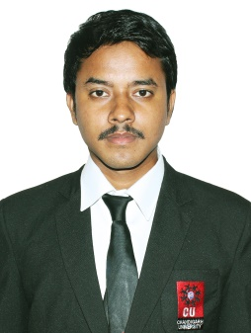

RINKU KUMAR DAS

Mob. No. Punjab: +91 9779706995, Assam: 8876304850

Email: jitu.2009.das@gmail.com
Present Address: GBM Apartment ,Chandigarh-Kurali Road ,Kharar -140301 .

Career Objective:

Looking forward a suitable opportunity in your esteemed organization, which gives me an ample opportunity where the organization goals and my carrier growth move in tandem.

Academic Qualification:

- Pursuing B.Sc. (H&HM) from Chandigarh University.
- 12th from Assam Higher Secondary Education Council (Ahsec).
- 10th from Central Board Of Secondary Education.

Others:
Certificate Course in Basic Computer Application
Diploma in Fine Arts

Achievements & Participation

- Got appreciation letter for working in C.A.B at Food Production.
- Achieve third prize in aaghaz party(Freshers Day).
- Got 2nd position in Casero Culinary at IIMT University (Meerut).
- Participated in “Amborisa” at Vidyajyoti Eduversity (Chandigarh).
- Got 1st Position for Regional Cuisine at Banarsidas Chandiwala Institute of Hotel Management Technology (New Delhi).
- Got Upcoming Chef Awards from Go Cheese Indian Chef Awards

Intership- The Leela ,Mumbai

Personal Details:

Name | Rinku Kumar Das.
Date of birth | 06/08/1994.
Mother’s name | Anjali Das.
Father’s name | Dwijen Chandra Das.
Gender | Male.
Nationality | Indian .
Permanent Address | Kamakya Coloney,aruna cinema hall bylane hillside near ganesh mandir ,Guwahati-781012,Assam (India).

Hobbies:

Accruing knowledge .
Learning new culture and the food habits.
Travelling.

DECLARATION:

I hereby declare that the above mentioned details are true to the best of my knowledge. I assure you that I will do my best to serve your organization.

RINKU KUMAR DAS

