ADDRESS:
S / o Sh. Gian Chand
H.No.2082/797, Sector - 10,
Badala Road, KHARAR,District-Mohali,
PUNJAB Pin – 140301
INDIA.
Mobile : +91-94174-92308
E-Mail = Sanju_dh531981@yahoo.com

Sanjiv Kumar Dhiman
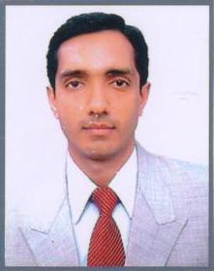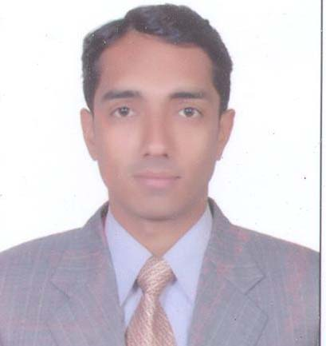
Objective:  Professional  Qualification:  Academic Qualification: | - “If given a chance I will work with my sincere efforts towards my organization and use my skills in the best possible way for achieving the organization’s goals”.  - Post Graduate Diploma in Accommodation Operation & Management from I.H.M. Kufri, Shimla.(H.P.) in May 2004 Under National Council for Hotel Management & Catering Technology PUSA. New Delhi.  Post Graduate Diploma in Computer Application from Punjab  Technical University, Jalandhar in 2002-2003.  - Graduation from Panjab University, Chandigarh in April 2001  - Senior Secondary from HPBSE, in March 1998.  - Matriculation from HPBSE, in March 1996.
Professional experience: | Presently Working with “Moksha Himalaya Spa Resort Parwanoo Himachal Pardesh” (A unit of Asia Resorts Limited) as a “ Front Office Manager” in Front Office Department From 2nd August 2019 To Till Date.  Worked with “Country Inn & Suites By Radisson Bathinda Punjab” (A Radisson Group of Hotels) as a “ Front Office Manager” in Front Office Department From 7th April 2017 To 31st July 2019.  Worked with “Country Inn & Suites By Radisson Sector – 12 Gurgaon” (A Radisson Group of Hotels) as a “Duty Manager” in Front Office Department From 15th Jan 2016 To 15th March 2017.  Worked with “ALOFT CHANDIGARH” (A Starwood Group of Hotels) as a “Front Office Executive” and “SPG Champion” in Front Office Department From 1st June 2013 To 9th Sept. 2015.  (Pre-Opening Team Member) Worked with “ALOFT CHANDIGARH” (A Starwood Group of Hotels) as a “Front Office Supervisor” in Front Office Department From 1st Sept 2011 To 31st May - 2013.  (Pre - Opening Team Member) Worked with "RAMADA JALANDHAR CITY CENTRE” (A Wyndham Group of Hotels) as a “Tr. Front Office Supervisor” in Front Office Department From 15th Jan. 2011 To 30th Aug.2011.  Worked with “TAJ CHANDIGARH” (A TAJ Group of Hotels) as a “Front Office Assistant” in Front Office Department From 27thAug. 2007 To 27th Aug. 2010.  (Pre – Opening Team Member) Done six months Industrial Training From 1st June 2004 to 30th Nov. 2004. & Worked with “THE DESTINATION” (A Best Western Group of Hotels) A Luxury Resort. Kandaghat, Shimla. (H.P.) as a “Front Office Assistant” From 1st Dec. 2004 to 3rd July 2006
Achievements & Appreciation Technical Skills: Achieved SPG Enrollment Goal in the 2014 as SPG Champion at Aloft Chandigarh Zirakpur. Received Appreciation Letter “Star Performer” for the Quarter Jan-2013 To March – 2013 and Many More at Aloft Chandigarh Zirakpur. Hotel Software =HOST, FIDELIO 6.24, PROLOGIC-WISHNET, OPERA 5.0. & FCS E – Connect. | Received Appreciation Letter “Bravo Award” at Country Inn & Suites By Carlson Sector – 12 Gurgaon.  Achieved SPG Enrollment Goal in the 2014 as SPG Champion at Aloft Chandigarh Zirakpur.  Received Appreciation Letter “Star Performer” for the Quarter Jan-2013  To March – 2013 and Many More at Aloft Chandigarh Zirakpur.  Hotel Software =HOST, FIDELIO 6.24, PROLOGIC-WISHNET,  OPERA 5.0. , IDS 6.5 & FCS E – Connect.
Passport No. | M 3229778
Personal Information: | Father Name : Sh. Gian Chand.  Date of Birth : 05-03-1981.  Sex : Male.  Martial Status : Married.  Nationality : Indian.  Languages Known : English, Hindi, and Punjabi.  Hobbies : Playing Cricket, Listening Music.
Declaration: | I hereby declare that the information furnished above is true to the best of my knowledge.
Date | Signature:

