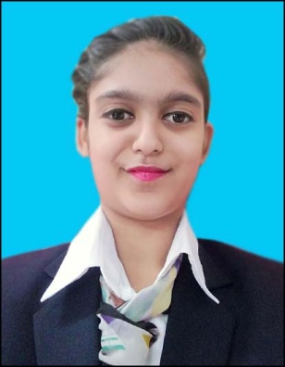 SHALINI ROY

B.SC IN HOSPITALITY & HOTEL ADMINISTRATION
E.MAIL – shaliniroy835@gmail.com
CONTACT – 9113122898
ADDRESS – SOUTH MITHLA COLONY, NASHRIGANJ, DIGHA, PATNA, BIHAR: 800018

EDUCATION
- B.SC IN HOSPITALITY & HOTEL ADMINISTRATION (2ND SEM)
University: JIS UNIVERSITY
College: GURU NANAK INSTITUTE OF HOTEL MANAGEMENT KOLKATA, INDIA.
Course start date: 01/08/2017 Expected graduation date: 08/2020.
College contact no. : 9432670426
College contact Email: info@gnhimac.in
College website: www.gnhim.ac.in

- HIGHER SECONDARY EXAMINATION
School: ST.DOMNIC SAVIOUS HIGH SCHOOL, PATNA.
Duration: 06/2015-06/2017
- SECONDARY SCHOOL EXAMINATION
School: ST.DOMNIC SAVIOUS HIGH SCHOOL, PATNA.
Passing: 2015
INTERPERSONAL SKILL
- Energetic and well disciplined
- Confident, Determined and Goal oriented
- Ability to cope up with different situations
PERSONAL DETAILS
Father’s name : Mr. Rajeev Rai
D.O.B : 20/10/1999
Language Known : Hindi & English
Martial Status : Single

