Curriculum Vitae

Siddharth Shukla
70,Sindhi Colony 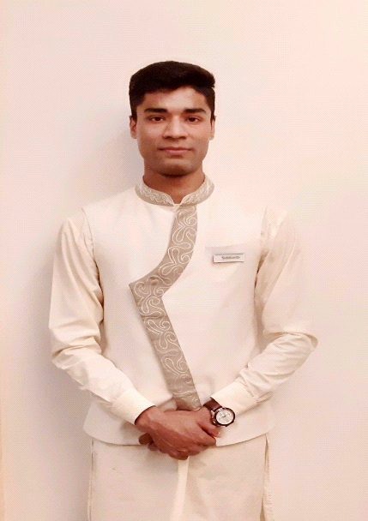
,Adarsh Nagar,
Near Pink Square Mall
Jaipur ,Pincode
Rajasthan
Contact No. +91 9414879165
E-mail- shukla90011@gmail.com

Career Objective
To Serve The organisation as a hard and a smart worker in this competitive environment discharging all my professional skills.
Willing to work with the Food And Beverage Service Department.

Summary
- Experienced Guest Service Representative with a Demonstrated History of Working in the Hospitality Industry .
- Skilled in research ,customer service,management,project management and social media .
- Strong support professional with a Bachelor of Science (BSc) focused in Food And Beverage Service from Institute Of Hotel Management Catering And Nutrition,Gurdaspur,Punjab.
Educational Qualification

- B.S.C In Hospitality And Hotel Administration Institute Of Hotel Management Catering And Nutrition,Gurdaspur,Punjab 2014-2017
- 12th Higher Senior Secondary From C.B.S.E in the year 2013.
- 10th Senior Secondary From C.B.S.C Board in the year 2011.

Computer Skills

- Microsoft Office
- Opera
- WIHMS
- Infrasys
- Micros
- E-Mail

Work Experience

- Industrial Trainee : 17 Weeks : The Oberois,Trident,Jaipur.

- Oct 2017 to Still Working Marriott International, Le Meridien Jaipur Resort And Spa as a Guest Service Agent in Food And Beverage Service.
- Worked with JW Marriott Mussoorie Walnut Grove Resort And Spa for 1 Month.

Duties & Responsibilities

- Responsible for keeping the Records Upto date.
- Responsible for providing the basic Knowledge of Food and Beverage operations to the staff.
- Responsible for the Store Indent And Making the Purchase Indent as per the Requirements.
- Responsible for providing the basic Knowledge for operating the system "Infrasys".
- Responsible for Making The Night Reports and Calculating the Food And Beverage revenue.
- Responsible for providing personalised service to the guest.
- Responsible for Handling the Shift.
- Responsible for providing the Butler Services to the guest on demand.
- Responsible for handling the operation of the speciality restaurant Under the name of Surya Vilas which is of 64 Cover which serves Rajasthani Cuisine.
- Worked With the Coffee Shop under the name of Latest Recipe which is the signature restaurant of the Entire Lé Méridien around the globe.
- Worked with the Banquets and also holding the experience of Providing the Butler Services to the guest on demand.
- Worked with In Room Dining.

Major Achievements

- Associate Appreciation Week. Awarded with a Trophy and a Certificate For Best Groomed Face of Le Meridien Jaipur of 2017-2018.
- Awarded with a certificate and a trophy for The Rockstar of LMJ 2019.
- Invented a Cocktail with a base of a white rum and whiskey named as After Republic.
- Invented a Mocktail named as Yogik Punch.
Hobbies
- Riding
- Driving
- Exercising
- Running
- Music
- Travelling
- Hangouts
- Web Surfing
- Football
- Shopping
Personal Detail
- Father’s Name : Mr Rajneesh Shukla
- Date of Birth : 01-08-1995
- Sex : Male
- Marital Status : Un Married
- Nationality : Indian
- Passport Number :N8133178

References

I hereby agree that the above furnished information are true from my knowledge & belief.

Jaipur, India

