Curriculum Vitae

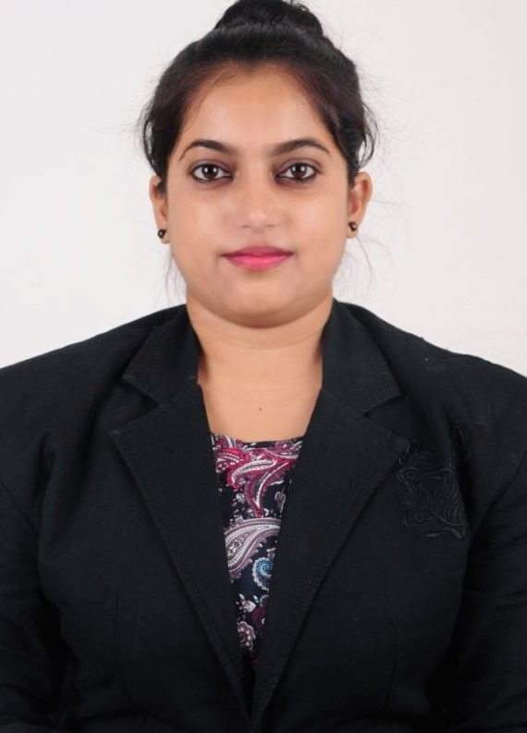

SUDHA PATKAR

Call : +91 9340696957,+919589076606
Email : Sudha.patkar12@gmail.com

Education

- PGDCA 2016/17
Makhanalal chaturvedi university Bhopal completed with 67%

- Bachelor degree 2012/15
APS university - B.com Economics completed with 53%

- Higher secondary 12th 2012
M.P. Board Bhopal successfully completed with 59%

- Secondary school 10th 2010
M.P. Board Bhopal successfully completed with 60%

Experience
- June 2018 present Working at Club Mahindra resort kanha M.P.
- Dec.2017-june 2018 7tiger resort tadoba Nagpur Maharashtra.
- Oct.2016-dec.2017 7tigers resort at kanha national park M.P.
- April 2015-march 2016 Syna Tiger Resort at bandhavgarh M.P.
- Feb.2011- jan.2014 Customer care officer in Micromax service rewa M.P.
KEY SKILLS AND COMPETENCIES
- All clerical Work, GSA, Call Attendant, Cash Book Handling, Stock Handling,front office, mail sending and etc.
- Having a professional manner with an emphasis on hospitality and guest service.
- Handling customer carefully.Computer operator/Office work.
- Tools & Application: MS Office 2007-8

Personal Details
DOB. : 20/06/1994
Postal Address. : Rewa(M.P.)
Pin : 486001
Marital status : Single
Langauge. : Hindi/ English
Date.............

