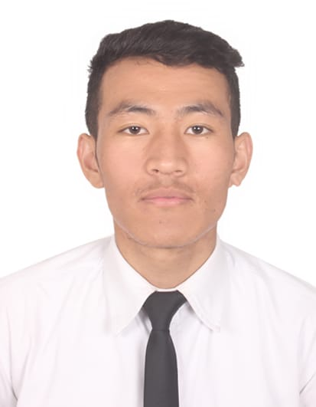
TENZIN DHONGAG

S.T. Bed extension, Tibetan Youth Hostel,
Bangalore, Karnataka 560047
iihm17blr025@iihmbangalore.com

OBJECTIVE:
To pursue a challenging and rewarding career opportunity to fully utilize my training and skills, while making a significant contribution to the success of the company.

EDUCATION: 2017-2020
- Pursuing Advanced Diploma in International Institute of Hotel Management, Bangalore.
- BA in hospitality management from University of West London at IIHM, Bangalore.
- Indra Gandhi National Open University (IGNOU)
- Tibetan SOS children’s village school Gopalpur, Distt.kangra (HP), (CBSE) 2017

EXPERIENCE:
Shangri-La hotel, Bengaluru
Industrial exposure training - 8th MAY 2018 – 12thOCTOBER 2018
Front office/ housekeeping / food and beverage/ food and production/human resources.
- Assisted guest with their luggage.
- Enhanced guest experience be performing concierge duties.
- Assisted HK team in cleaning the guest room, public area.
- Trained in laundry.
- Fulfilled complete table service duties including taking food orders, cleaning table and settings tables.
- Trained in various section of the food and production and enhanced my culinary skills.

LEADERSHIP AND CAMPUS INVOLVEMENT
- Attended Housekeeping master class by IHCL hotels in Bangalore.
- President of (GLOBAL TIBETAN STUDENT UNION SOUTH ZONE) 2019
- Member of (GTSU) (GLOBAL TIBETAN STUDENT UNION SOUTH ZONE) 2018
- Leadership workshop by Central Tibetan Administration.
- Front office members during college fest.
- Coordinating team member at young chef Olympiad.
- Buddies for young chef Olympiad.
- Décor team during college fest.

OTHERS
- Hobby: Love to sing and play sports, reading books and travelling.
- Skill: fluent in Tibetan language, ladakhi, English and Hindi.

