UTTAM LIMBU
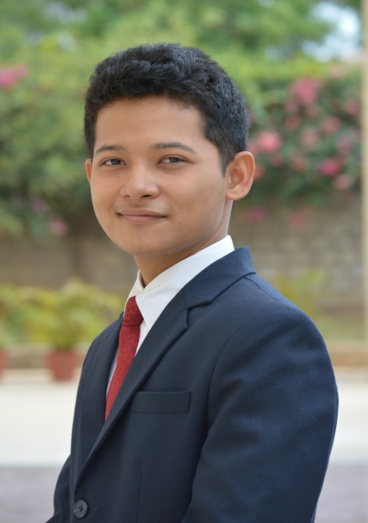
S/O Nb/Sub Indra Bahadur Limbu
Permanent Address: C/O Sohab Khan, Khaprail
Darjeeling - 734009
Date of Birth: 19 JULY 1995
Mobile: +919870501317
Email : uttamlimbu1907@gmail.com

Career objective:
To become associated with a company where I can utilize my skills and gain further experience while enhancing company’s productivity and reputation.

Educational Qualifications:

Course | Board/ Institution/ University | Year of completion | Division
BHM  (Pursuing) | BANGALORE UNIVERSITY | 2017 | FIRST CLASS
XII  (Science) | ARMY PUBLIC SCHOOL 1, LUCKNOW | 2012 | FIRST CLASS
X | ARMY PUBLIC SCHOOL 1, LUCKNOW | 2010 | 8.8 CGPA

Industrial Exposure:
- Have undergone my Industrial Training for 4 months in all core departments from VIVANTA BY TAJ, LUCKNOW successfully.
- Have undergone specialization in FRONT OFFICE department for 2 months from VIVANTA BY TAJ, LUCKNOW successfully.
Work Experience

- Worked at Praxis Services Pvt Ltd as Senior Reservation Sales Associate 1 year 5 months from Aug 2017 till Jan 2019.

Hobbies and Interests:
- Playing football
- Playing guitar
- Watching anime series

Language proficiency: English, Hindi & Nepali

