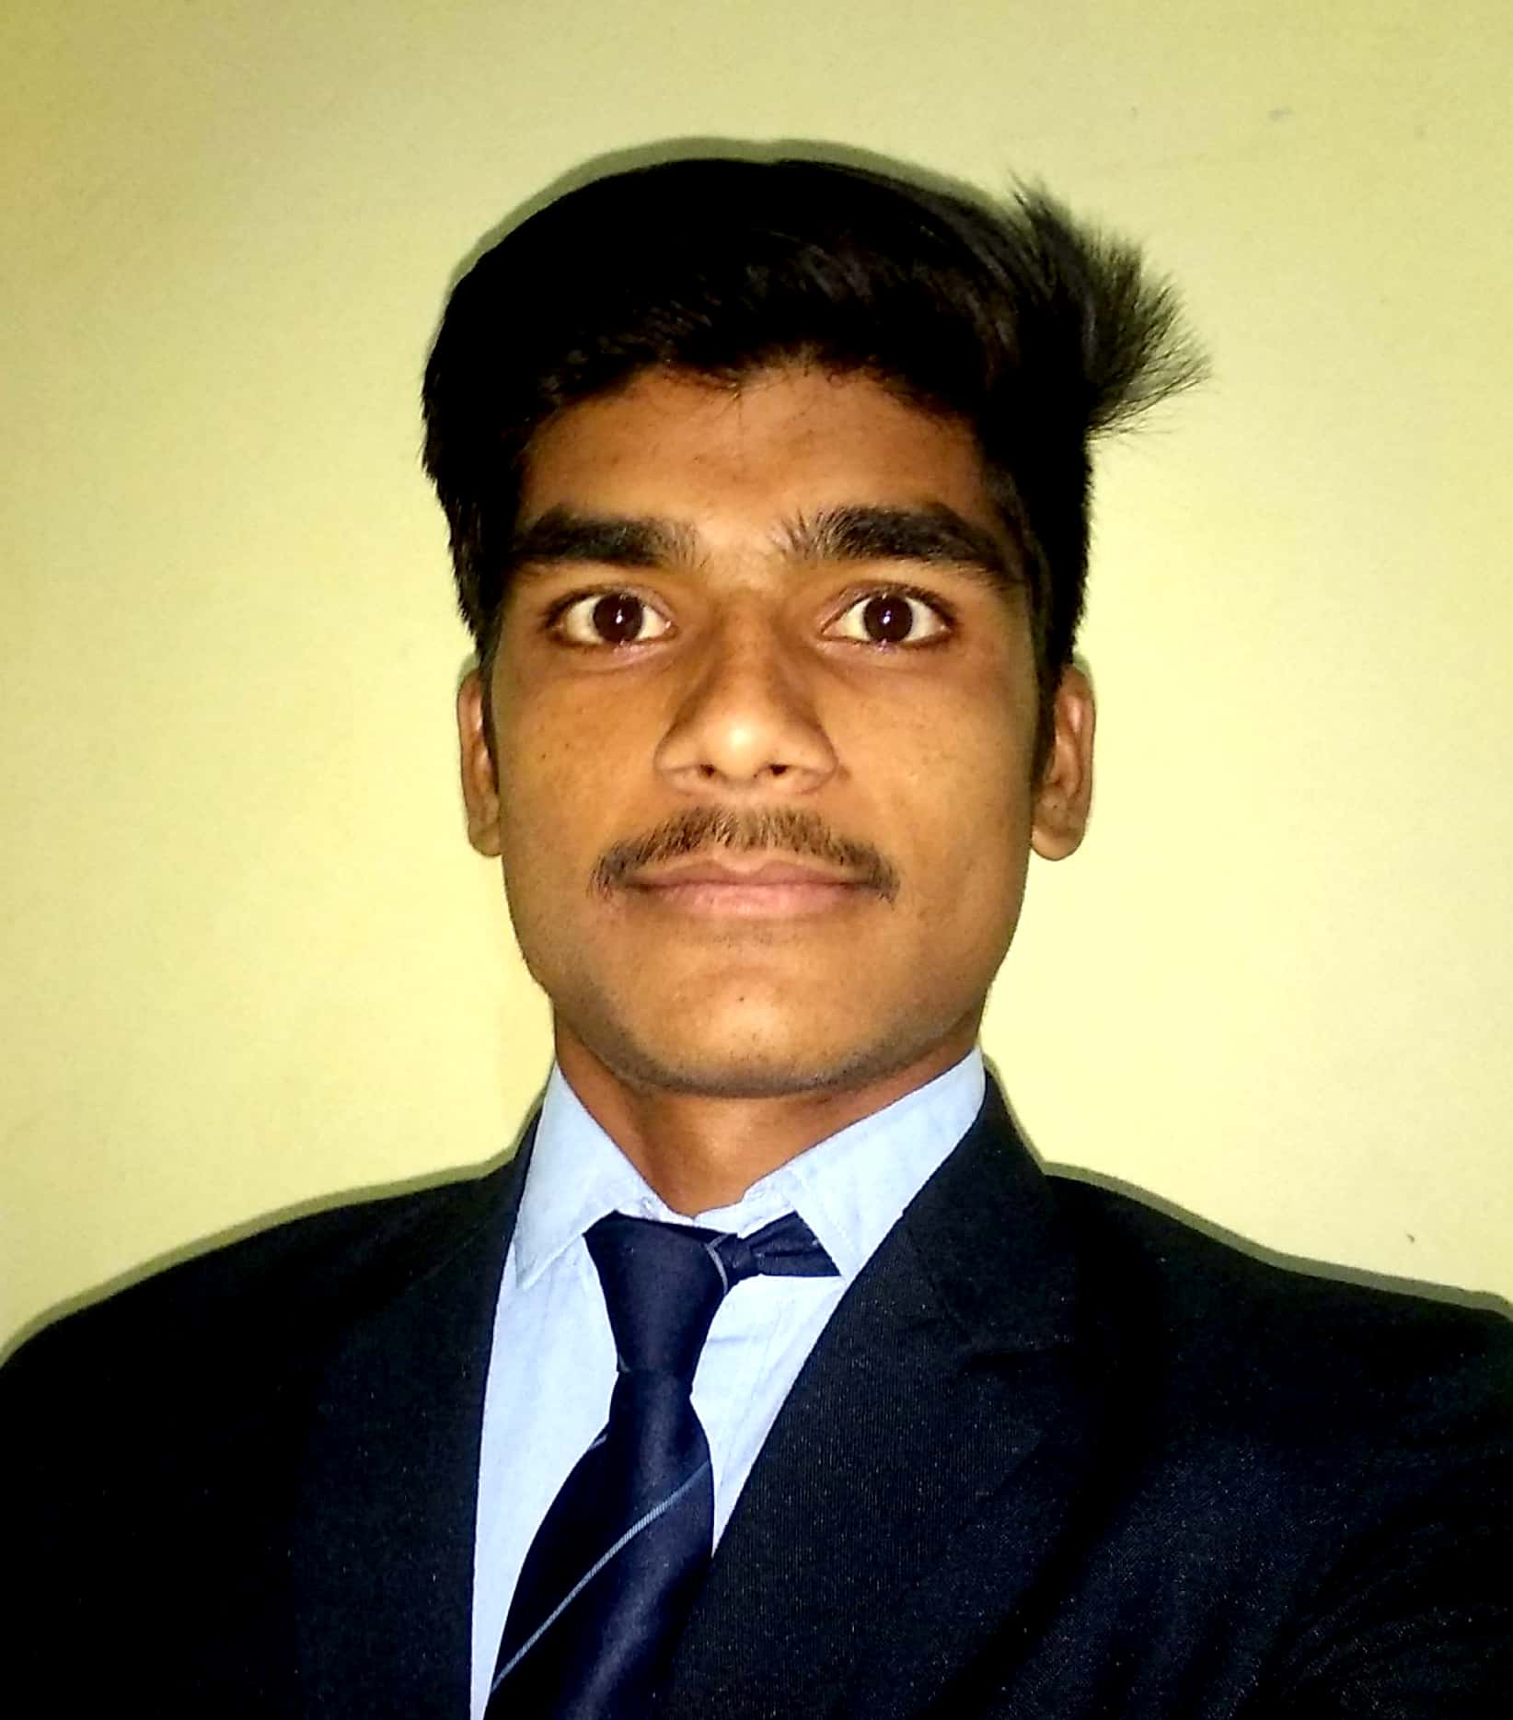
Name:- Vikas Aajinath Phuke

Email: -vikasphuke697@gmail.com

Mobile No: -9527261480

RESUME

CAREER OBJECTIVE

To work for an organization which provides me the opportunity to improve my skills and knowledge, to grow along with the organization objectives.

ACADEMIC DETAILS

Examination | Institute | University | Percentage | Year
TYDHMCT | Maharashtra State Institute Of Hotel Management Pune. | MSBTE | 60.55% | 2019
H.S.C | Maharashtra College Aurangabad | Maharashtra Board | 63.00% | 2016
S.S.C. | Ramrao Patil Vidyalaya Gevrai  Aurangabad | Maharashtra Board | 75.00% | 2013

TECHNICAL QUALIFICATION: MSCIT

HOBBIES : Traveling, Sport, Swimming

LANGUAGES KNOWN : English , Hindi And Marathi, Basic knowledge of French.

Reference Personnels 1)Aparna Deshpande (Training and Placement Officer)

ACTIVITIES:
EXTRA CURRICULAR ACTIVITIES
- Completed Four Months Industrial Training at Hotel Rama International Aurangabad Scheduled from 1st Dec 2017 To 30th Mar 2018.
- During Training I worked in F&B Service, Housekeeping, kitchen

STRENGTH
- Patience
- Good team player
- Positive Attitude

PERSONAL DETAILS

Address : Nimkheda Phulambri Aurangabad
Date of Birth : 07/04/1997
Marital Status : Unmarried
Gender : Male

Date: / /
Place: Pune ( Vikas Aajinath Phuke)

