VISHNU M  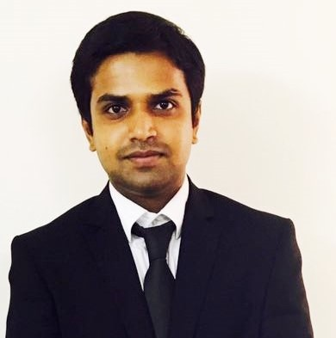  E-mail:  vishnu13bm@gmail.com  Contact Number  Mobile: +91 7034597087  PASSPORT NUMBER  R0845764  EXPIRY DATE  05/06/2027  PRESENT Address  No 64B 3rd street  Rajagopalapuram  Moulivakkam  Porur Chennai  PIN:600125  PERMANENT Address  Sree Kesava Nivas  Oortukala  Neyyatinkara  Trivandrum  Pin 695121  Personal Data  Date of Birth : 13/11/1994  Sex : Male  Nationality : Indian  Marital Status : Single  Languages Known  English  Malayalam  Tamil  Hobbies  Cooking  Cricket  Carroms | curriculum vitae  Objective  My objective is to work for an organization which provides me the opportunity to improve my skills and knowledge to growth along with the organization objective  Educational Qualifications  - Completed 10th at st.pauls higher secondry school  - Successfully completed Bachelor’s Preparatory Programme,2016  Professional Qualification  Completed (3 year) diploma in Hotel Management and Degree in Tourism Science in EMIRATES MUNNAR CATERING COLLEGE, UAE  Personal Skills  - Organizing and managing capabilities  - Positive attitude.  - Good communication skills.  - Dedicated, focused, enthusiastic and hard working  Computer Proficiency  - M.S office  - Hardware&Networking
Work experience

- COMPLETED FOUR MONTHS INDUSTRIAL EXPOSURE TRAINING AT RADISSON JASS HOTEL KHAJURAHO M.P INDIA
- COMPLETES SIX MONTHS INTERNSHIP AT HILTON GARDEN INN AL-MINA DUBAI
- WORKED AT POOVAR ISLAND RESORT AS RESERVATION AGENT.

Field Strength

- Active Member Of food production Committee
- Good communicative
- Team player

Extra Curricular Activities.
- Food production committee member in college.
- Has participated in several cultural activities school vise

Area of Interest

All the areas of a hotel, with an added passion towards Food production, Housekeeping , concieage

Declaration

I hereby declare that the abovefurnished information is absolute according to the records and to the best of my knowledge.

VISHNU M

