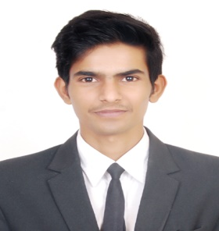
YESHPAL SINGH

Mobile No: +91 8880063344 email id –yashpalsingh3344@gmail.com

Objective:

I am a high motivated person looking for an organization where I can enhance my knowledge and give my best to the organization. Hence I would like to seek a job in your venerated hotel so as to gain experience for a future career. My strength is my dedication to the job that I am given, my team work skills and my genuine interest in that job.

Skills & Strength

- Positive attitude
- Enthusiastic
- Energetic with ability to learn
- Hardworking
- Self-confidence
- Excellent communication skills
- Ability to work calmly even under pressure & in harmony

Accomplishment

- Completed industrial training at HYATT REGENCY CHANDIGARH.
- Experience of outdoor catering in TAJ West End Bangalore, Sheraton Grand Hotel, Shangri-La Hotel, The Aero India 2017, ITC, Oberoi Bangalore
Windsor Manor, ITC Gardenia, Leela Palalce, The Ritz Carlton (Bengaluru).

Achievement:

- Digital Marketing Certified 2016.

- Participated in basic Fire Fighting Training 2017.

- Volunteer in National Social Service Camp (NSS) 2018.

- Diploma in Desktop Publishing :- from ITECH Institute of Computers, Bangalore, Karnataka

- National Cadet Corps (NCC) B Certification with ‘A’ Grade.

- Education:Bachelin Hotel Management
- (IHE), Bengaluru
- Certification of Continuous and Comprehensive Evaluation for 10th Standard from CBSE Board :- from DAV Public School, Ghumarwin, Himachal Pradesh Awarded 60%
- II PUC Examination Certification :- from M.S RAMAIAH PRE-UNIVERSITY COLLEGE, Bangalore, Karnataka Awarded 65%

Personal Profile:

- Date of Birth : 20 February 1998
- Marital status : Single.
- Religion : Hindu
- Nationality : Indian

Hobbies & Interests:

- Listening to music
- Cricket
- Exploring
- Travelling

Languages Known:

- English
- Hindi
- Punjabi

About Me:

I am a person with positive attitude, I’m the kind of person who never back down from the job that I have been assign.

YESHPAL SINGH

