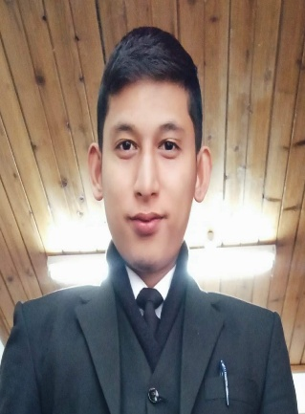
PRASANT TAMANG
Salbari, PO Methibari
Siliguri, Dist. Darjeeling, West Bengal 734009

CAREER OBJECTIVE:
To work with an organization that would give me opportunity for personal growth and enhance my professional skills in the service industry.

INDUSTRIAL TRAINING EXPOSURE:
● 2017: Industrial Training in Grand Hyatt hotel Goa

WORK EXPERIENCE:
●2017: Taj falaknuma palace [1YEAR 2 MONTH]
● 2019: Renaissance race course hotel Bangalore [ Marrorit Hotel ]

DUTIES AND RESPONSIBILITIE
● addressed all customer requests promptly.
● obtained food and entered into POS system.
● served food and beverages as per restaurant standard
● ensured serving station is clean and fully stocked.
● Inspected food and quality, presentation and temperature.
● followed proper food handling and storage practice.
● Ability to take guest beverage and food orders efficiently
● Ability to retrieve and deliver food and beverage orders in a timely manner
● Ability to ensure guest satisfaction throughout the meal service

EDUCATIONAL QUALIFICATION:

NAME OF EXAMINATION | BORAD/UNIVERSITY | YEAR
Secondary | SEBA , Assam | 2011
H.S(ARTS) | SEBA , Assam | 2013
B.A (GRADUATION) | G.U(Guwahati University) | 2016
Trade Diploma in F&B service | NCHMCT , IHM GANGTOK | 2017

STRENGTHS:
●Self Confident
●Good Communication Skills
●Knowledge of Computers
●Willingness to learn

PERSONAL PROFILE:
●Date of birth : 16/02/1996
●Father’s Name : Mani Kumar Tamang
●Gender : Male
●Marital Status : unmarried
●Nationality : Indian
●Religion : Buddhist
●Language Known : English, Nepali & Hindi, Assamese
●Hobbies : Football
●Height : 5.5 [165.50 Cm]

To whomsoever it may concern: All the details and information proved by me are 100% true to the best of my knowledge

THANKING YOU
PRASANT TAMANG
(M) 91-7432024818

